Dear children,
We are excited to welcome you to school in September.
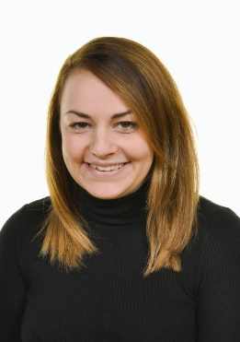

My name is Miss Marker and I will be your class teacher in Early Years Foundation Stage.
I love to be creative and I really enjoy reading.
I enjoy being outside and love welly walks.

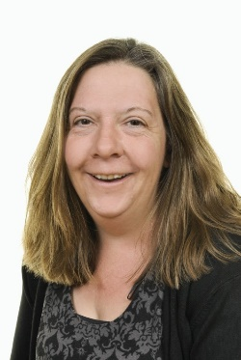

My name is Mrs Franklin and I will be your class teaching assistant.
When I am not at school, I love walking my dog and cooking yummy cakes.
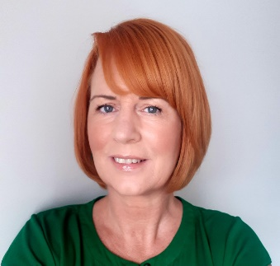
I enjoy visiting Cornwall.

My name is Mrs Crossing and I will be your class teaching assistant.
I enjoy cycling and reading.
I enjoy spending time with my family who live in different places.

